**ELECTRODYNAMICS**

**DBE MAY/JUNE 2025**

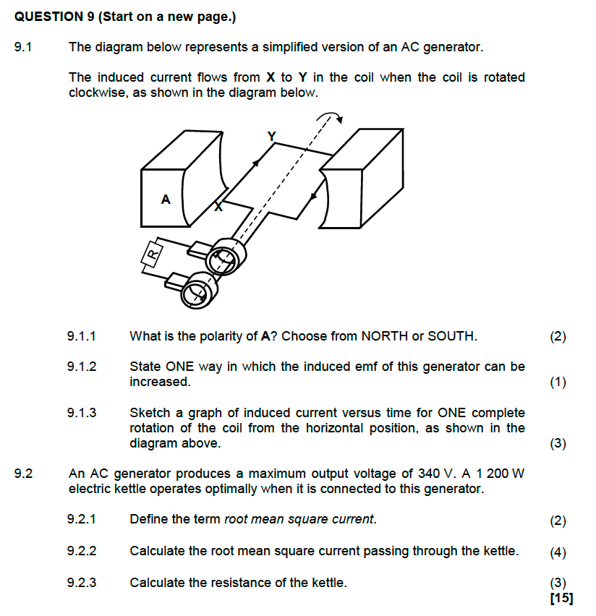

**GAUTENG SEPTEMBER 2024**

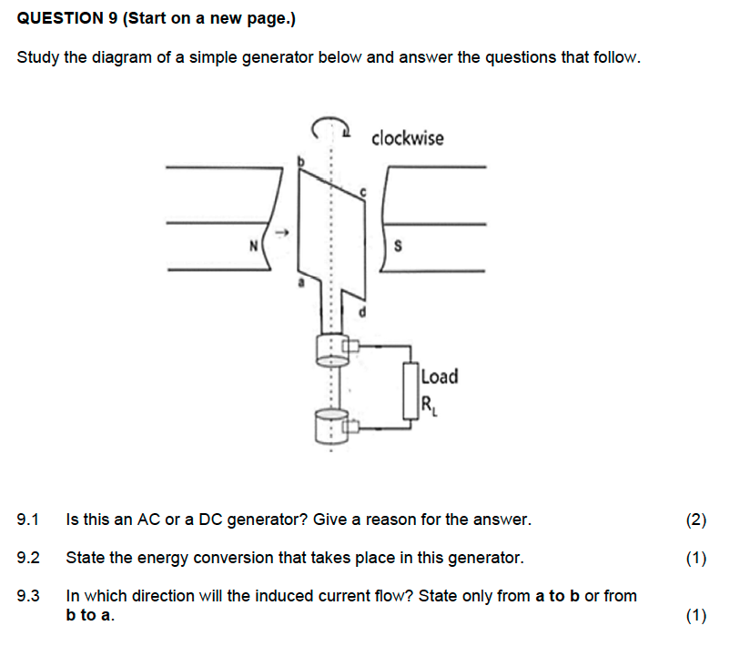

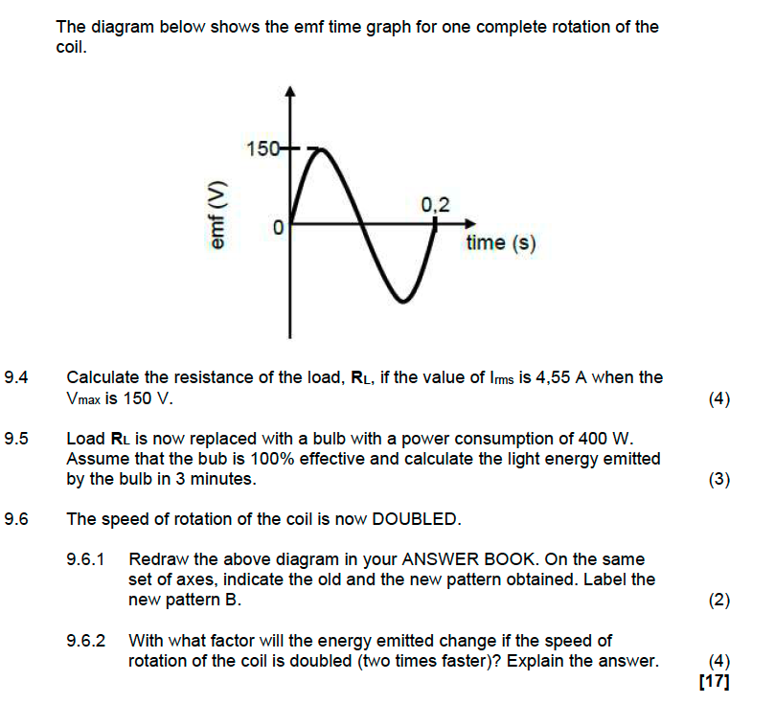

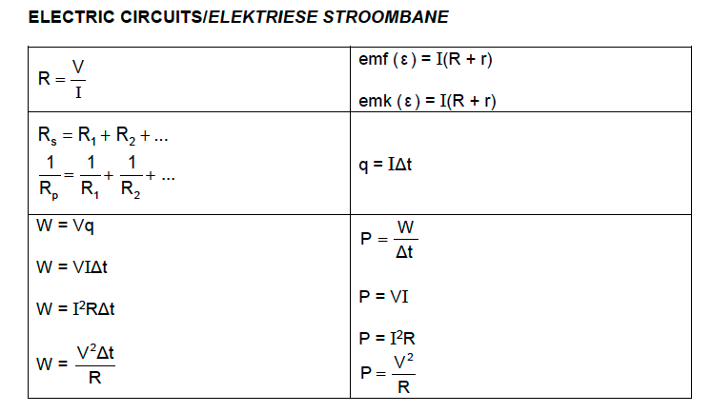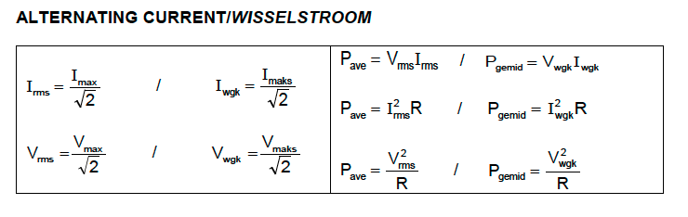

Good luck with your exams! Remember: Practice! Practice! Practice!